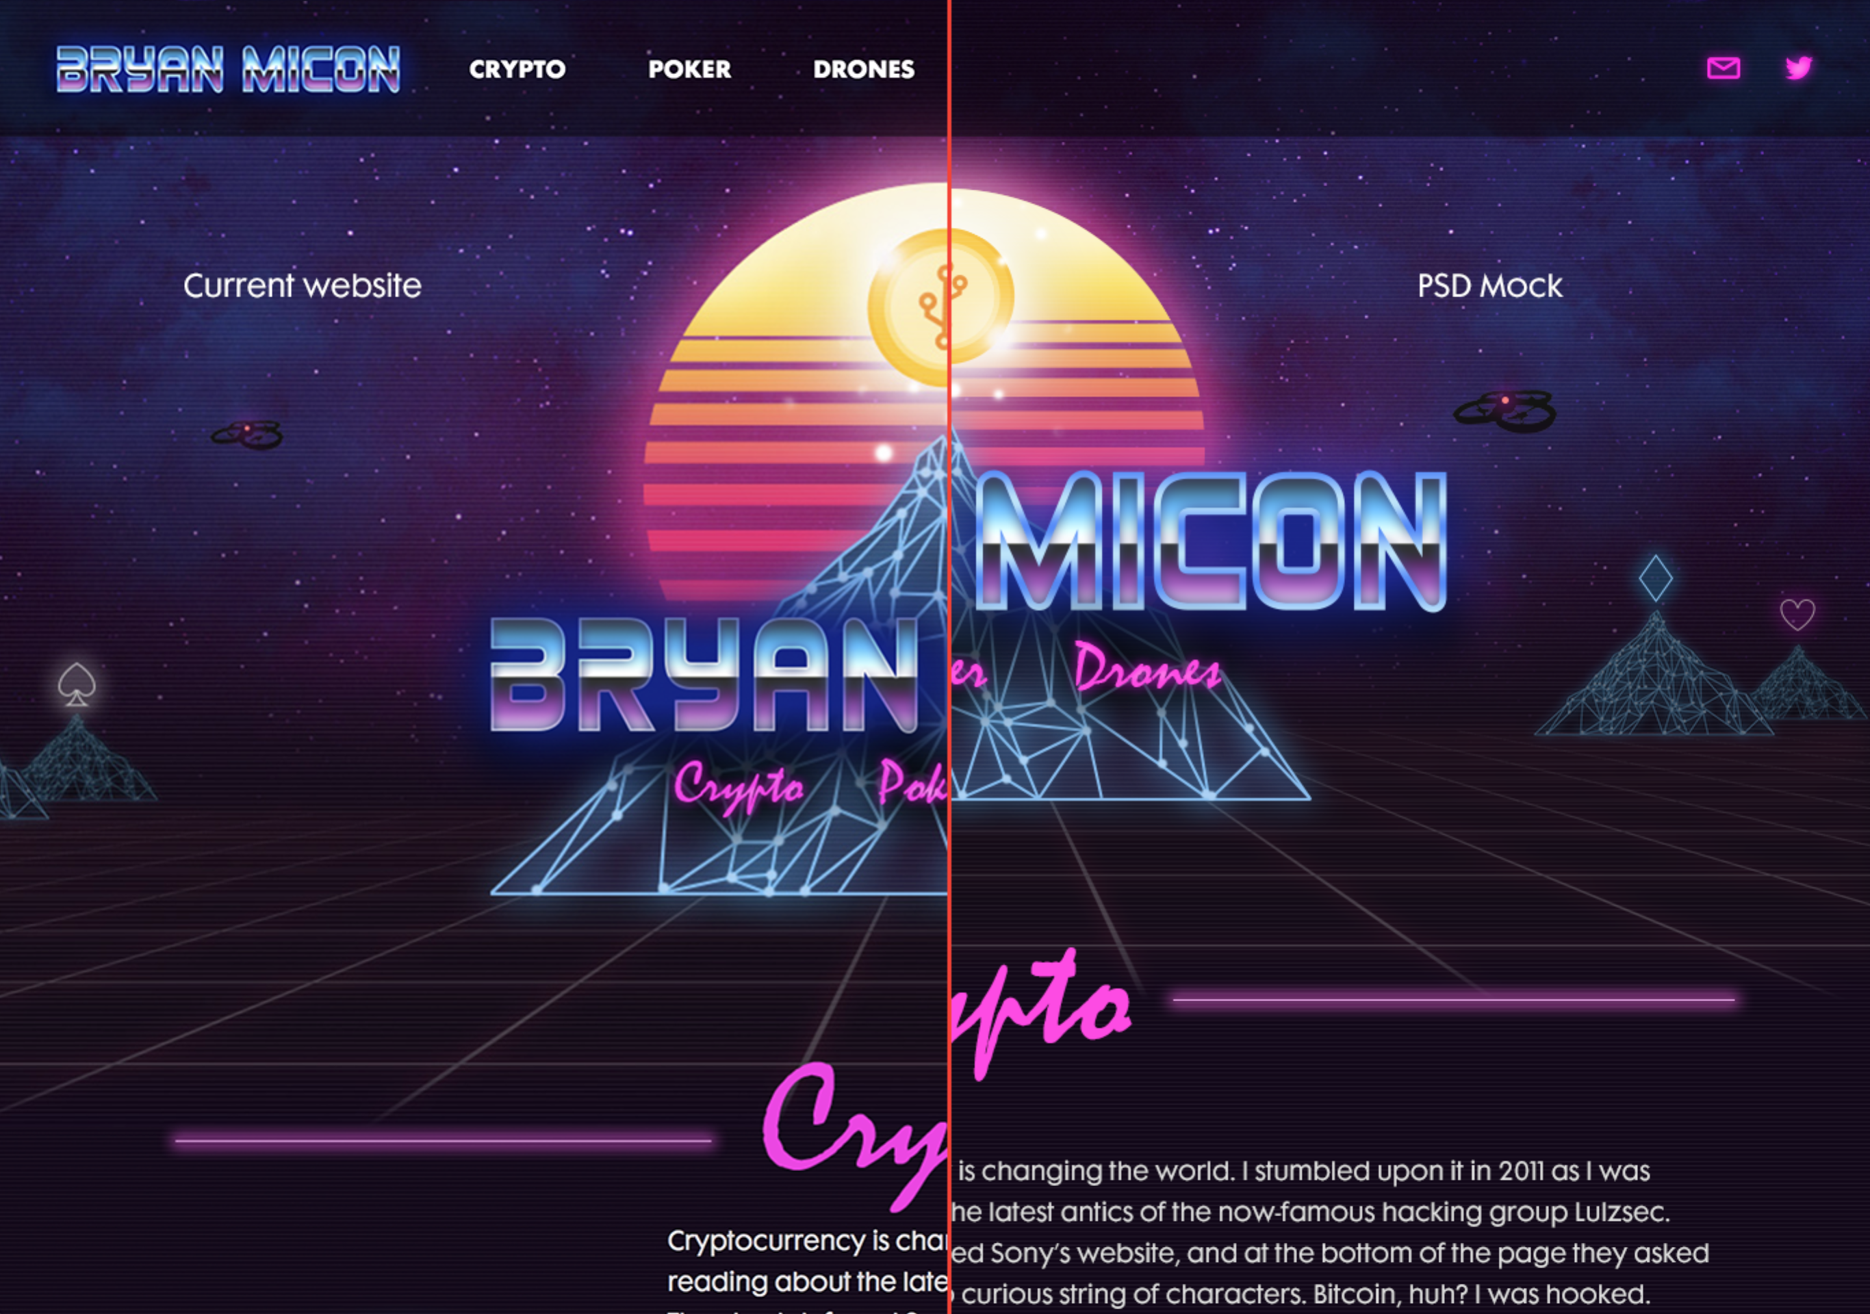

Hero

Both of these images are at 1366px. The left is the current dev site the right is the original mockup. On the dev site the bg hero is significantly bigger than it’s supposed to be. You’ll also notice that the title is also significantly smaller and the placement is off. The thickness around the letters has been changed for some reason. I’m not sure the reason for any of this.

Crytpo Section

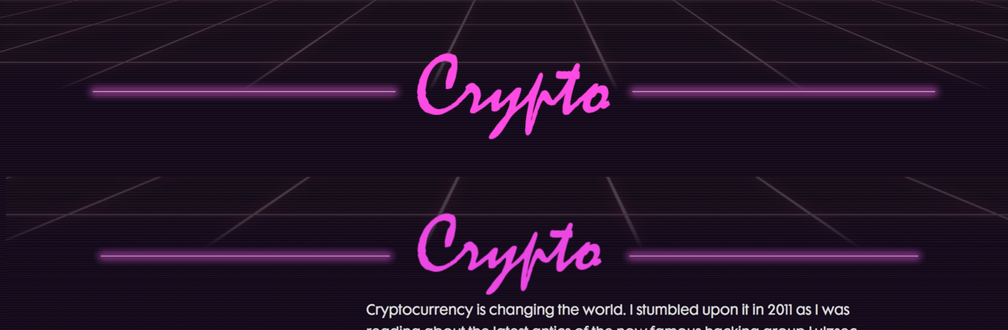

The top image is the mock up the bottom is the dev site. The title on dev is a bit smaller as well as the lines on the left and right. Spacing is off a little as well. Those aren’t as big of an issue as the space between the title and the paragraph copy. Should be around 50ish pixels. Maybe a little more, 53 at the most.

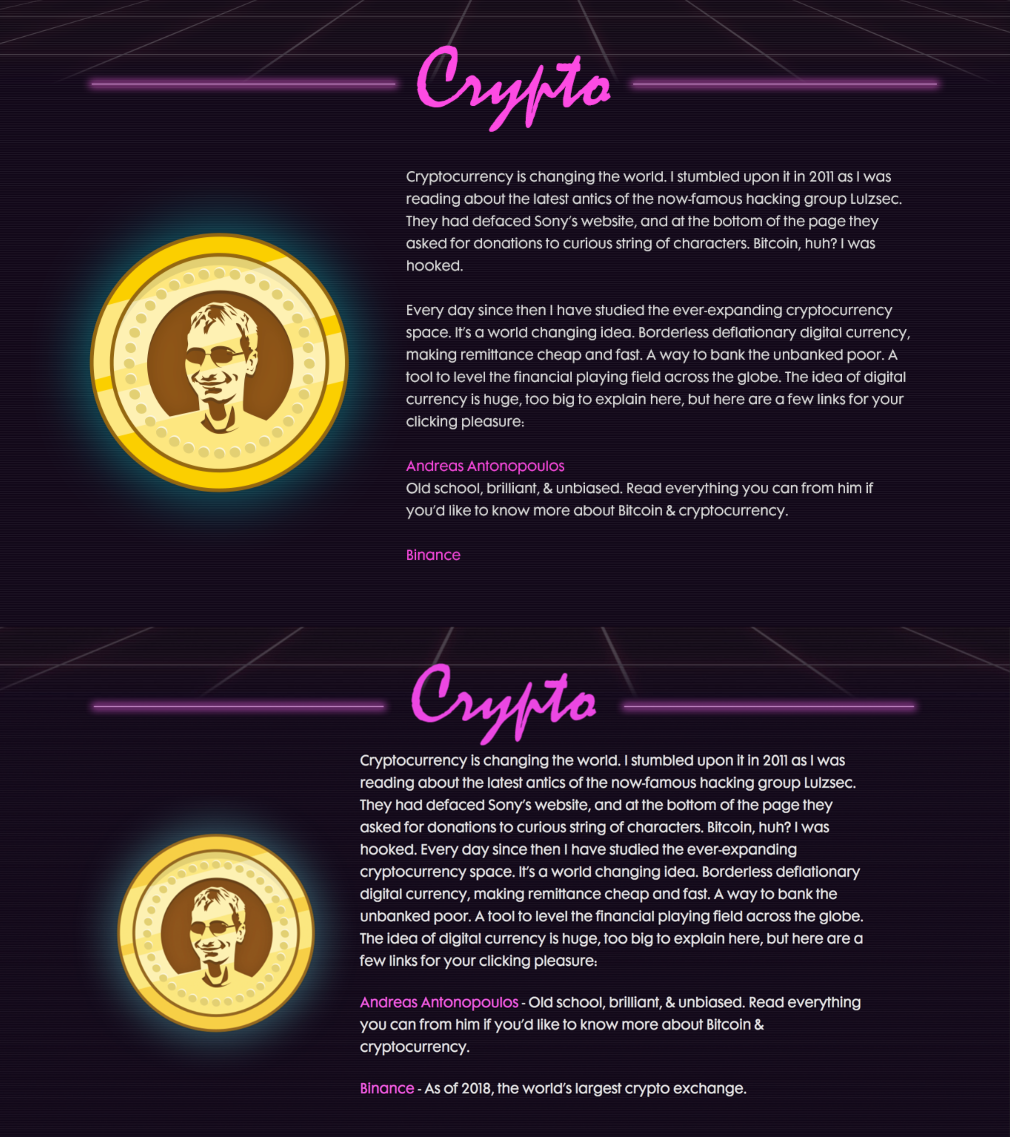

The top is the mockup the bottom is the dev site. Notice the difference in size of the coin. Also, notice the placement of the content block which hasn’t been adjusted in this new formatting of the copy.

I’ve reformatted the content block to be at 382. The lines break a little better this way. Not so ragged at the end. I’ve also added a paragraph break and adjusted the copy down below a little so that is reads a little better.

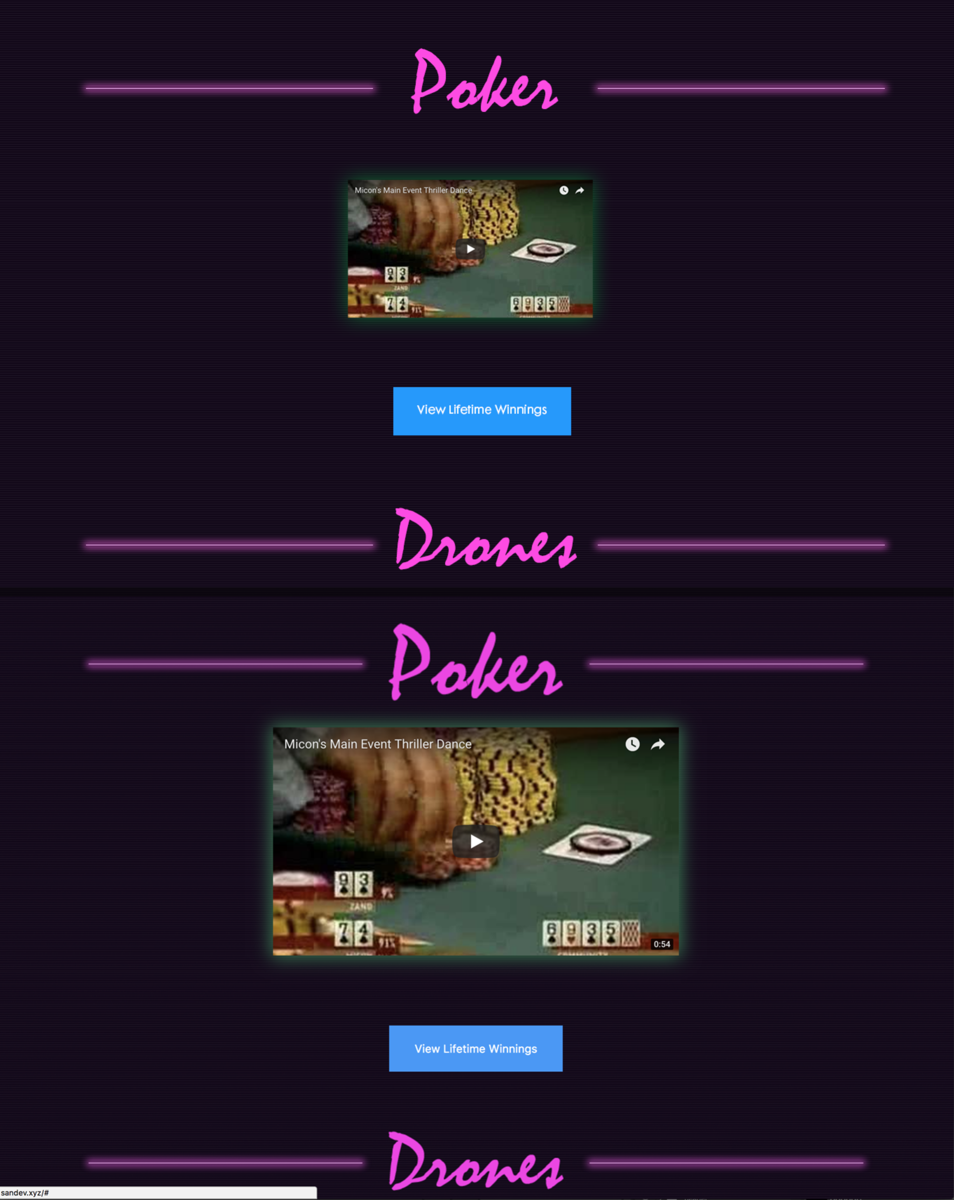

The top is the mockup the bottom is the dev site. Notice the difference in size of the videos. The mockup is at 350 with 16:9 ar. The bottom one is at 580. When they are this big you can’t get 3 on a row which is important on the “Drones” section.

Notice the difference in size of the titles. Mockup is much smaller. The margin of space between the title and video is significantly different. The bottom margin isn’t as significant but there’s definitely a difference.

This same styling can be applied to the “Drones” section as well. It pretty much the same section only with more videos.

The only other issue that’s not in the mock up is the transparency of the bar for the top navigation. When you start scrolling over the content the nav gets hard to read. I would change the opacity to 80% to eliminate this issue.

If there are any questions or need clarity please let me know. I’m more than happy to help out so that it looks the way it’s supposed to. I’m not asking for an exact match to the pixel of the mock up, but these mistakes are pretty significant when it comes to the overall aesthetic of the site. Getting within a few pixels is acceptable. When in doubt please open the PSD and measure.